MODEL EXAMINATION 1

DSA0150 – OBJECT ORIEANTED PROGRAMMING WITH C++ INTERACTIVE GAMES

Name: N Santhosh Kumar Reddy

Reg no: 192211691

Ques no 8:

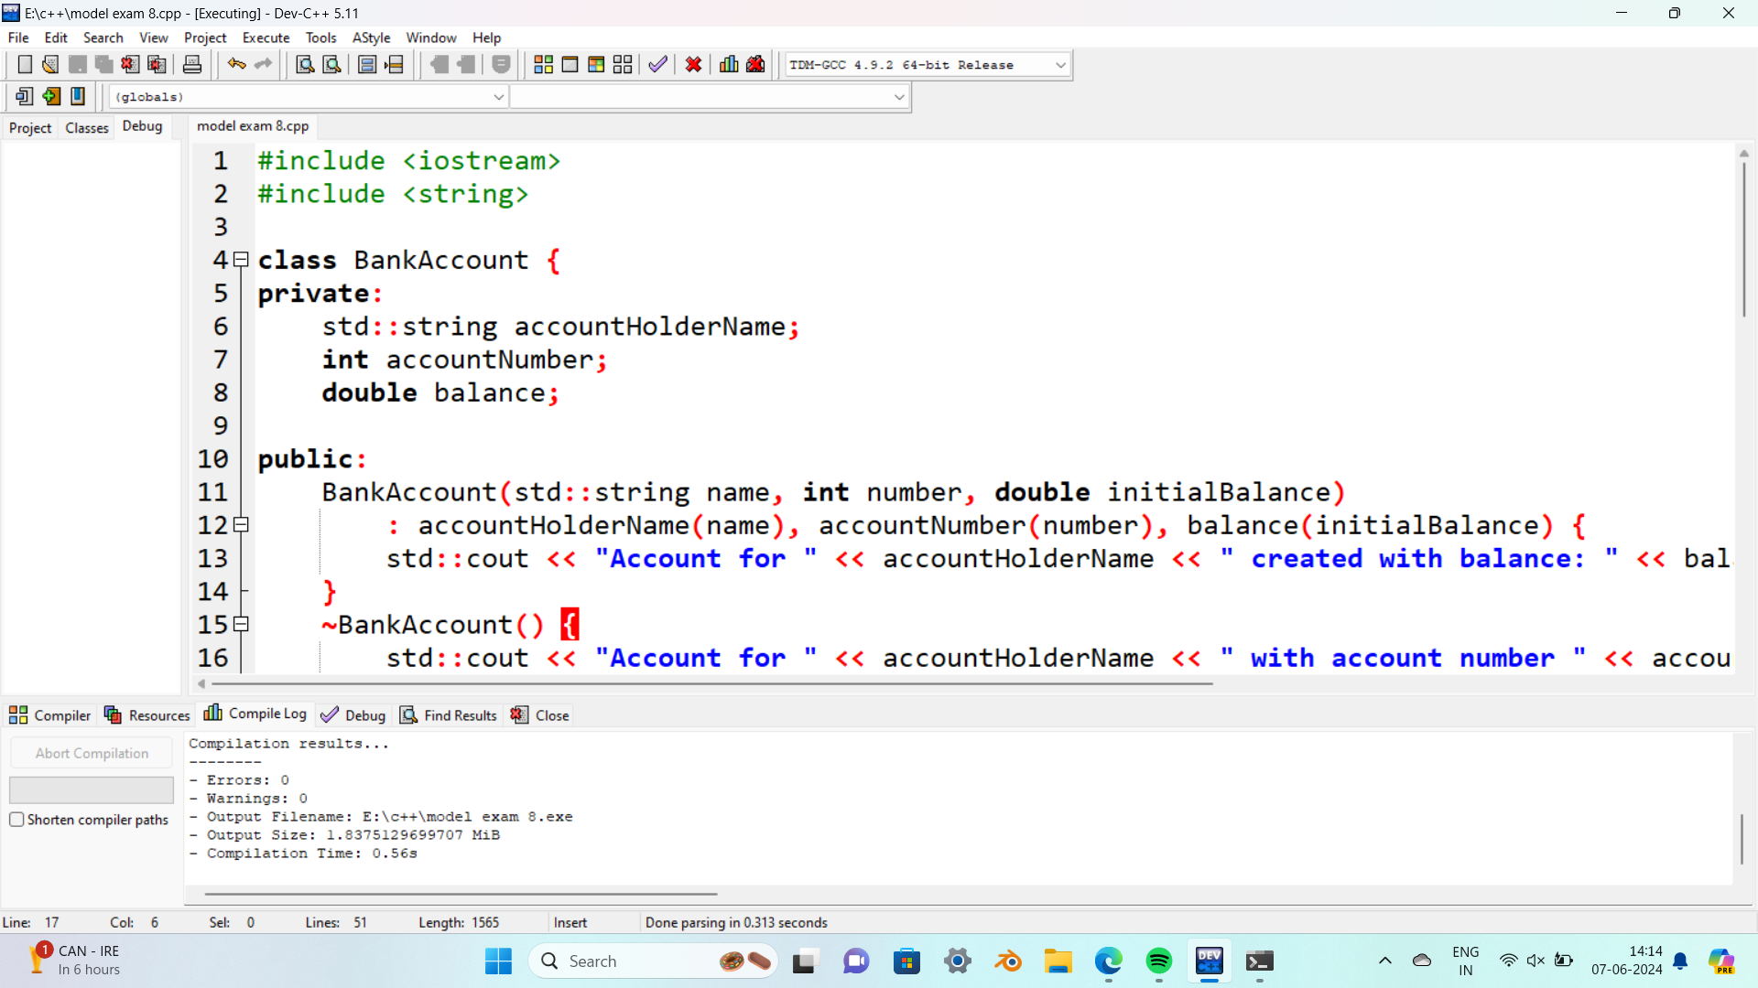

OUTPUT:

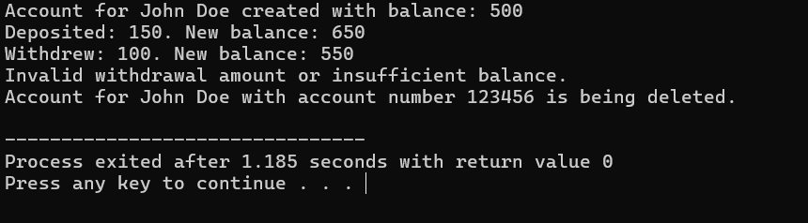

QUES 1

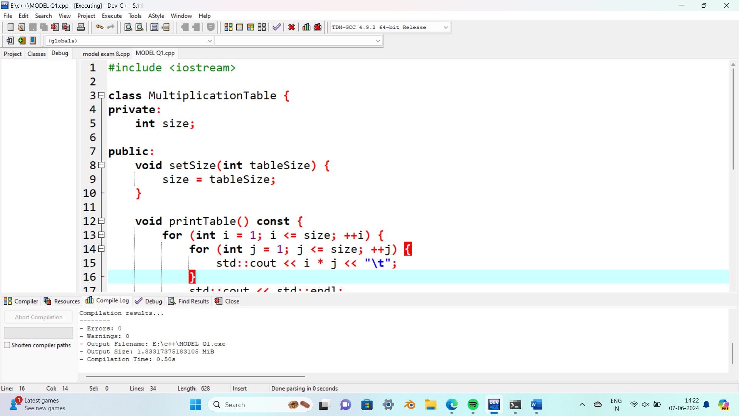

OUTPUT:

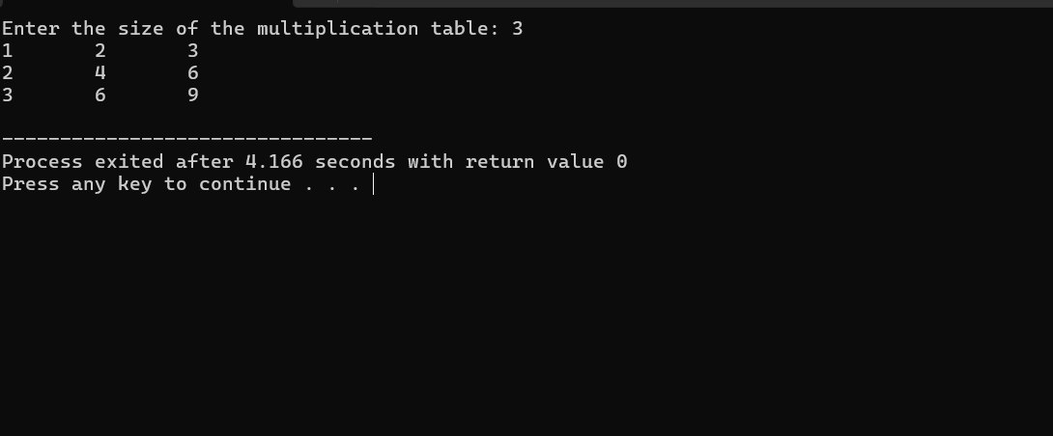

QUES 2:

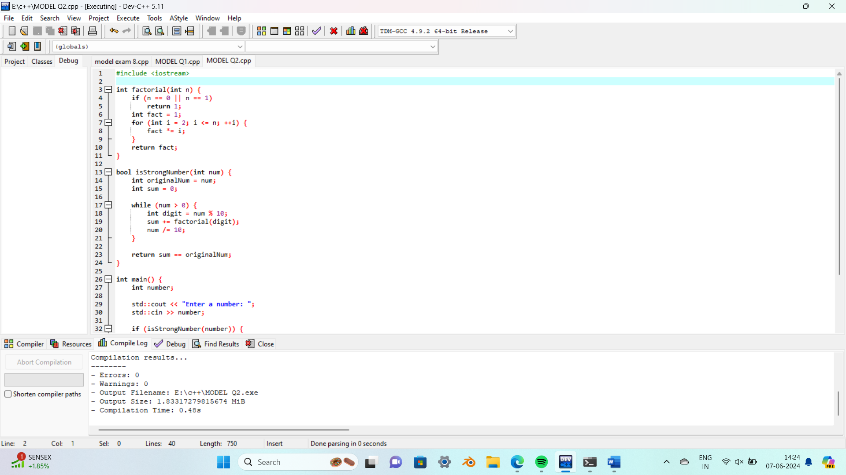

OUTPUT:

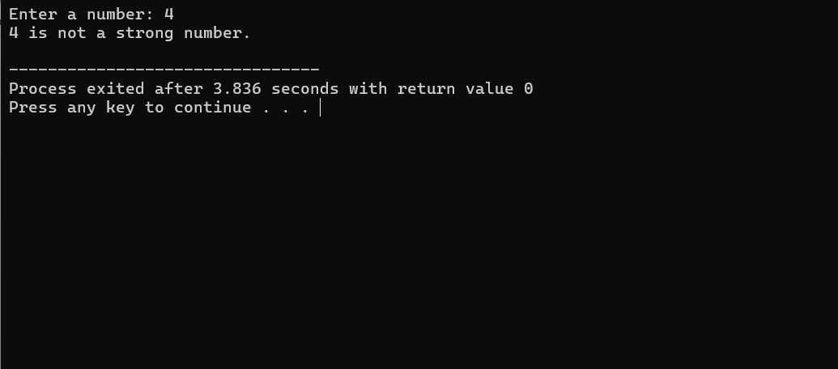

QUES 3:

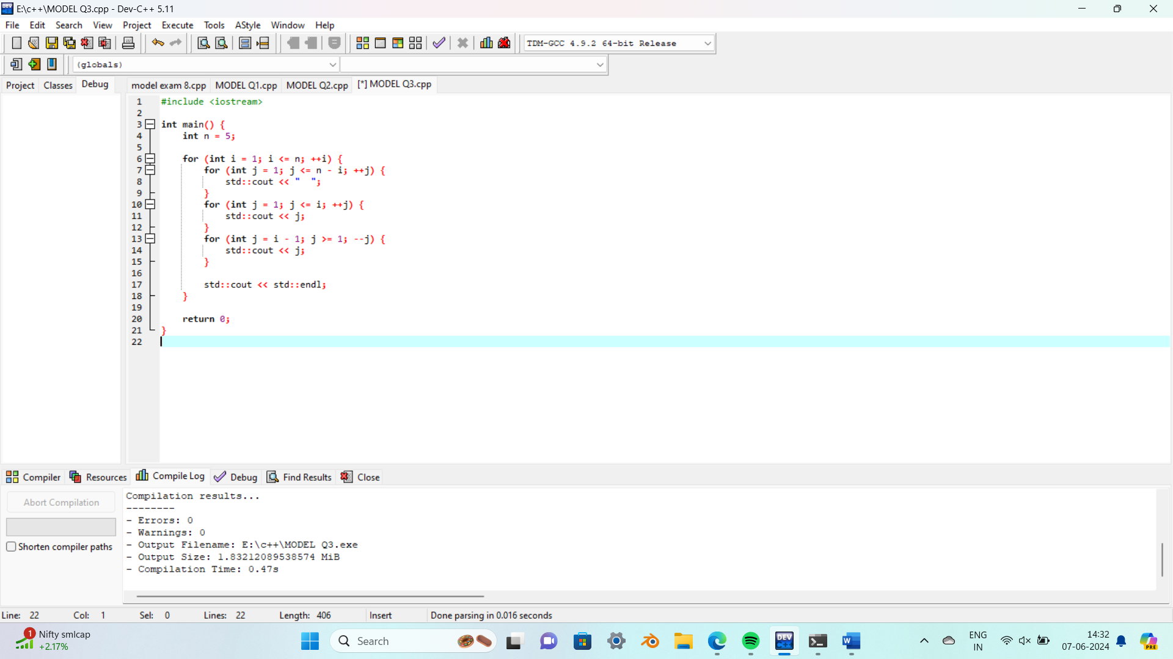

OUTPUT:

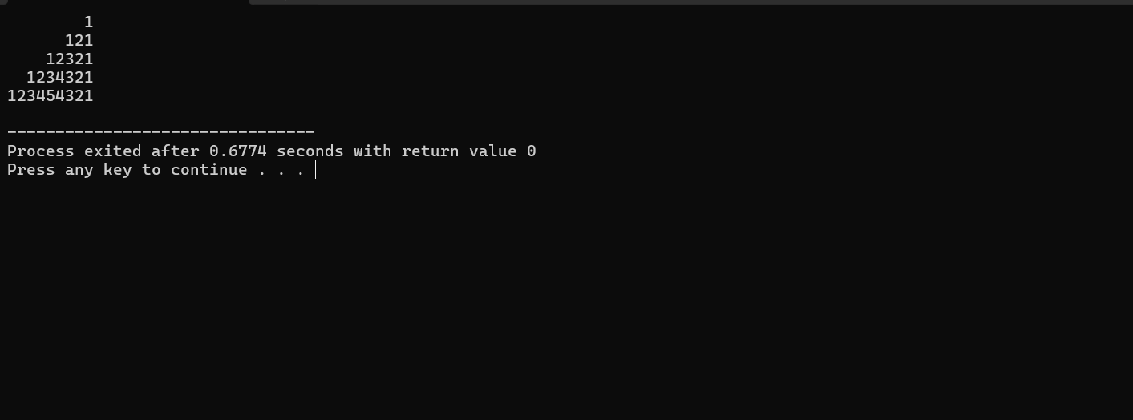

QUES 4:

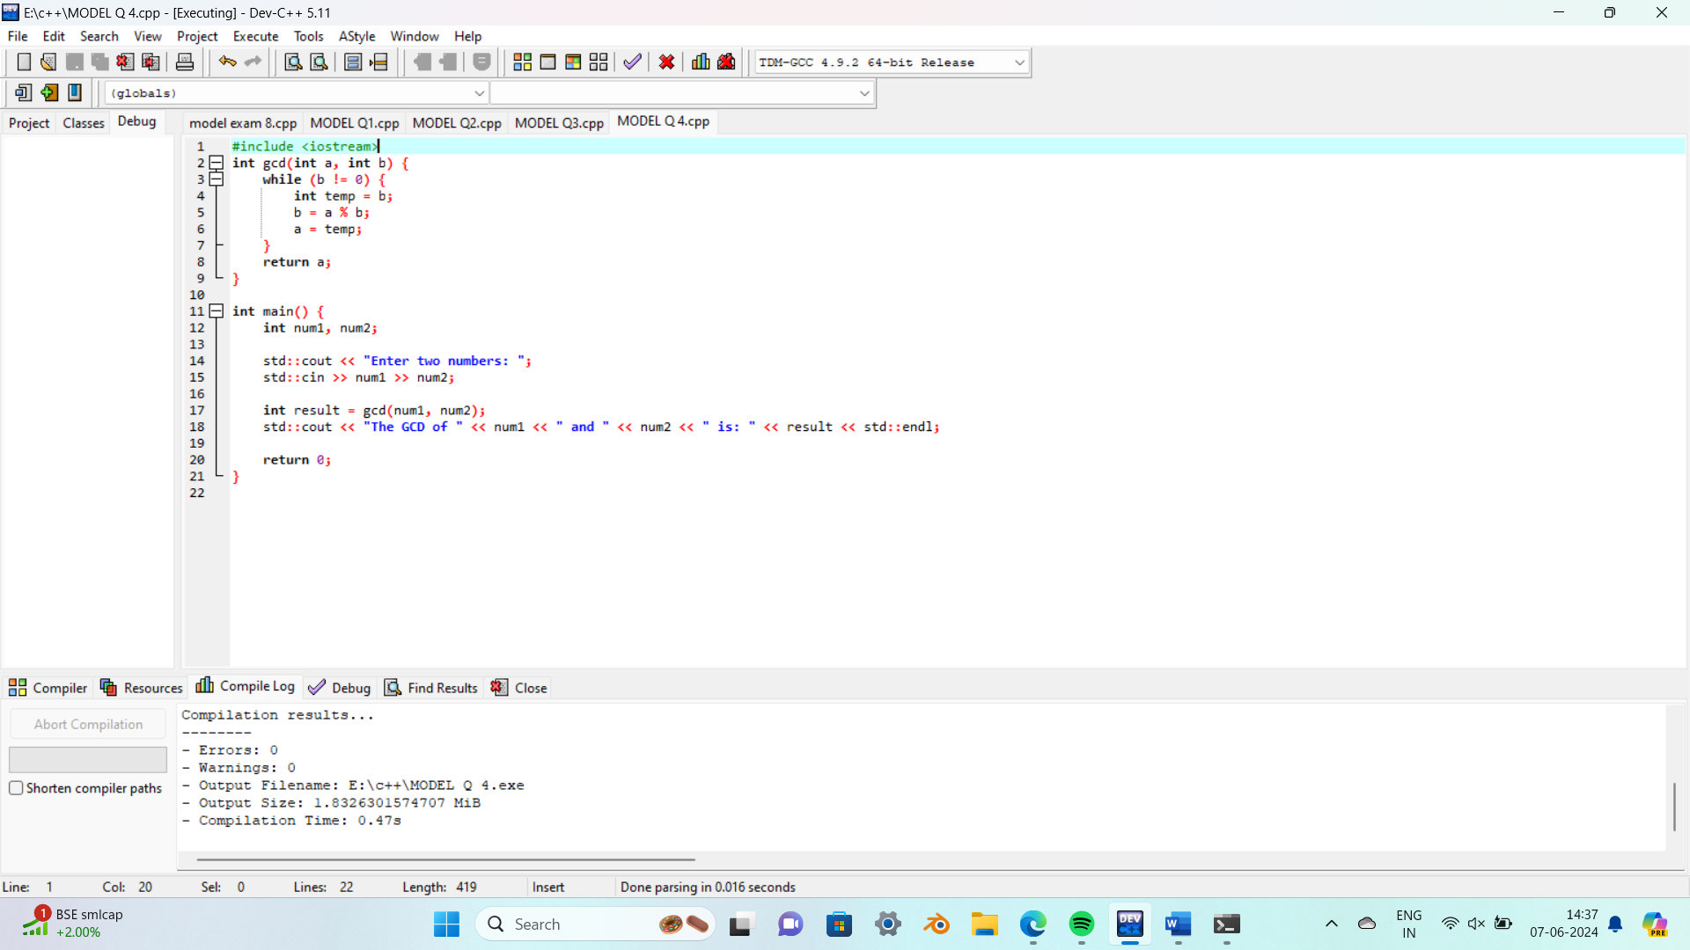

OUTPUT:

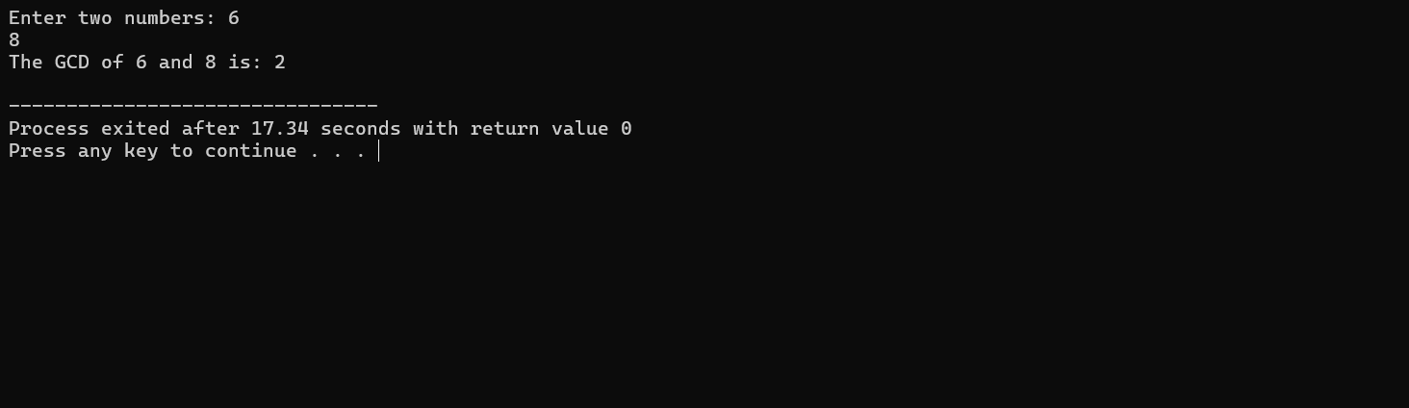

QUES 5:

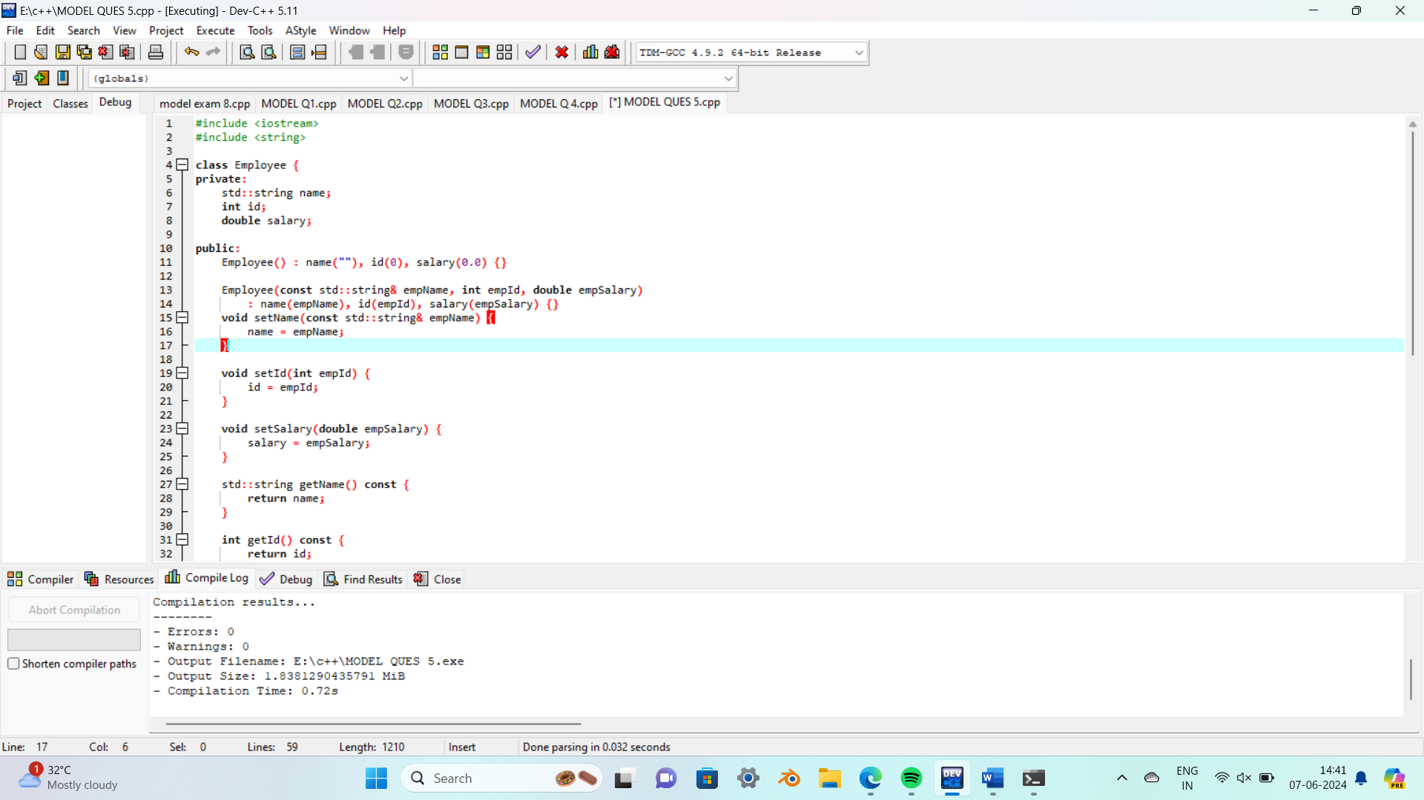

OUTPUT:

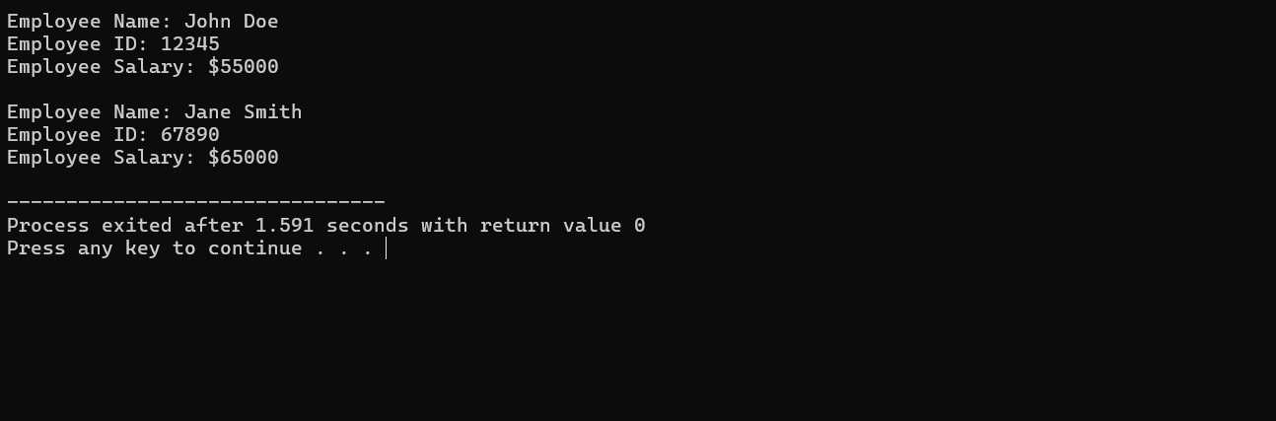

QUES 6:

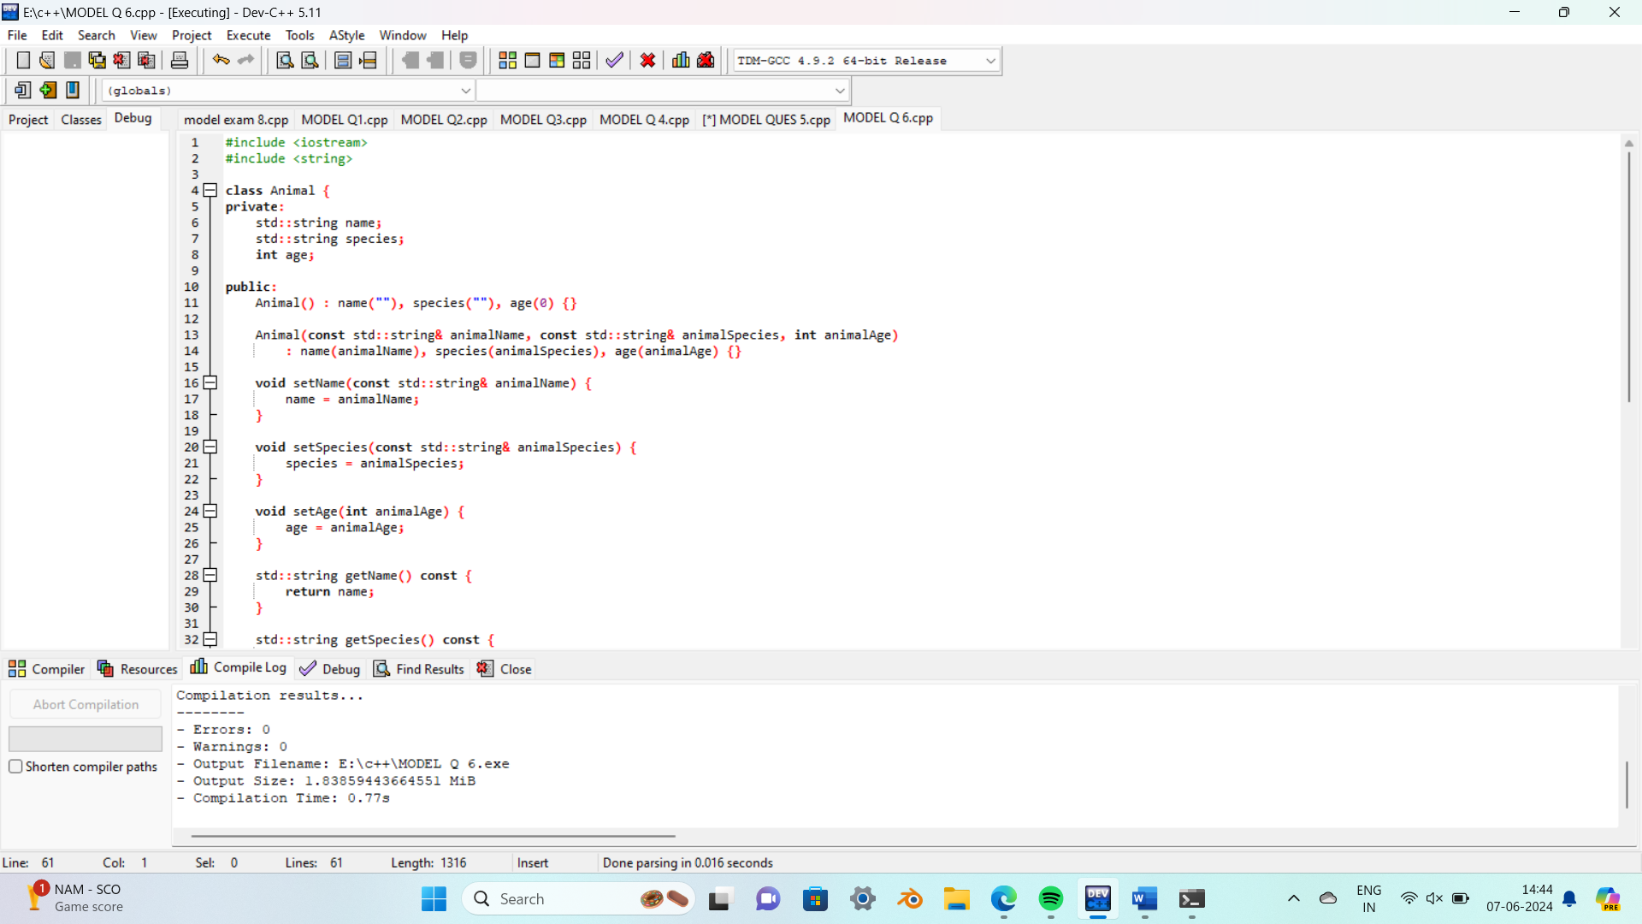

OUTPUT:

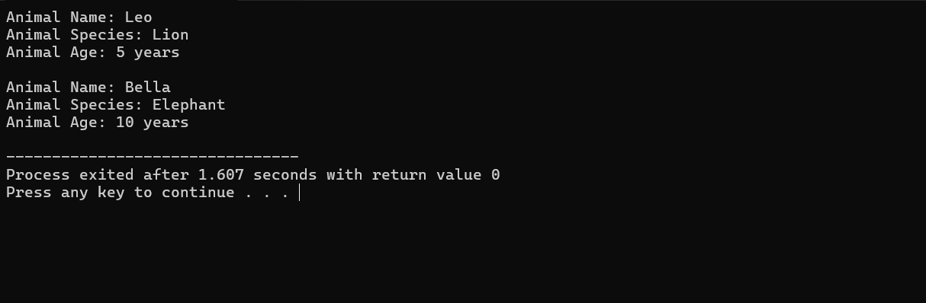

QUES 8:

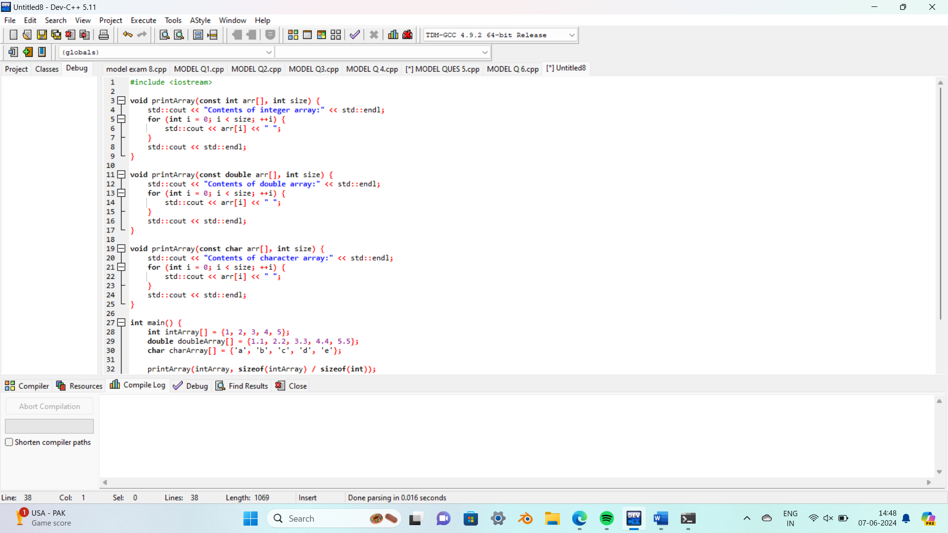

OUTPUT:

